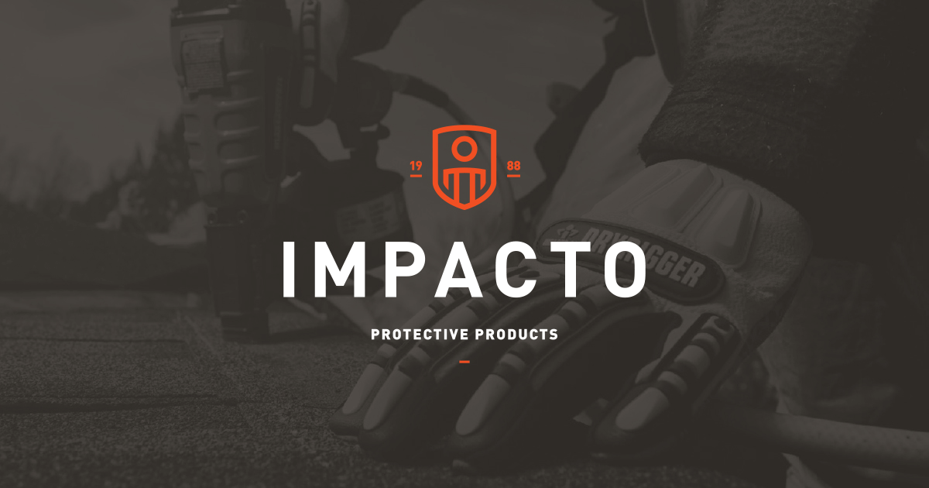

Industrial Sewing Machine Operator
Impacto Protective Products - Belleville, ON

Who We Are
We are a privately-owned business that has been operating in Belleville for over 35 years.

What We Do
We are in the safety business! We make and distribute personal protective equipment to reduce the likelihood of injury and make working as comfortable as possible.

At our manufacturing facility in Belleville, we sew, finish, and package products for distribution globally.

What It’s Like to Work at Impacto
Many of our employees have worked here for over 20 years, and some even 30 years! We think that means people enjoy and value working here, and we’re proud of that. We provide opportunities for career advancement and prefer to promote from within. Many of our employees have moved up to more senior positions with our support to train and develop them as needed.

- We are hiring for Industrial Sewers.

- Do you have previous sewing experience, even as a hobby?

- Are you good with your hands and enjoy detailed work?

- Want to turn your hobby and natural skills into a secure paying job with company-paid benefits?

If you answered yes, to any of the above questions we want to hear from you!

We are also willing to train candidates who can demonstrate aptitude for sewing.

THE POSITION:

The Industrial Sewer is a key member of the production team. The Sewer is required to use various equipment and work as a team with others to complete orders, working with quality, precision, and in a safe manner.

DUTIES AND RESPONSIBILITIES

- Sew one or more operations on the product assigned by the Production Manager.
- Operate industrial sewing machines including flatbed, serger, bartack, glove turner, and other sewing machines, to join sections of garments or other articles into finished products.
- Operate specialized sewing machines; side arms, buttonholing, etc. as experience is gained.
- Learn and use the most efficient methods of sewing various products.
- Cooperate with the Production Manager when required to assist in training others.
- Perform minor maintenance and repairs on sewing equipment including cleaning, oiling, and making minor adjustments to optimize performance.
- Maintain a clean and tidy work area ensuring safety at all times.

QUALIFICATIONS & ESSENTIAL SKILLS

- Previous industrial sewing machine experience or several years of experience operating a sewing machine even as a hobby is preferred but not necessary.
- We are willing to train those with little or no sewing skills who show demonstrated aptitude on our sewing and dexterity assessments.

Essential Skills
Reading, writing, counting, hand-eye coordination, manual dexterity, detail-oriented, ability to work independently or as a team. High school diploma or equivalent preferred, but not essential.

PHYSICAL ENVIRONMENT

General light manufacturing environment; repetitive tasks, prolonged periods of sitting, combination of sitting, standing, and walking.

Our production employees work Monday to Friday 7:00 am to 3:30 pm. We do not operate evening or night shifts. Are you available for full time work from 7 am - 3:30 Monday to Friday every week.

Experience: • sewing or home sewing: 2 years (required) Shift availability: • Day Shift (required) Work Location: In person

